Experiment 4

Geometric Transformation and Filtering Using OpenCV

# Aim:

To implement the following Geometric Transformations a Filtering functions on an image in Open CV:

1. Translation, Rotation, Affine Transformation and Perspective Transformation
2. 2D convolution, Averaging and Blurring
3. Thresholding

# Software/ Packages Used:

1. Pycharm IDE
2. Libraries used:
   * NumPy
   * opencv-python
   * matplotlib
   * scipy

# Programs:

**1)Geometric Transformations**

#Translation #Rotation

# Affine Transformation #Perspective Transformation **2)Filtering**

#Image Blurring #Gausian Blurring #Median Blurring

#Bilateral Filtering #Average Blurring **3)Thresholding** #Simple #Adaptive

#Ostu’s

## 1)Geometric Transformation (Output):



(Input Image- Colour)

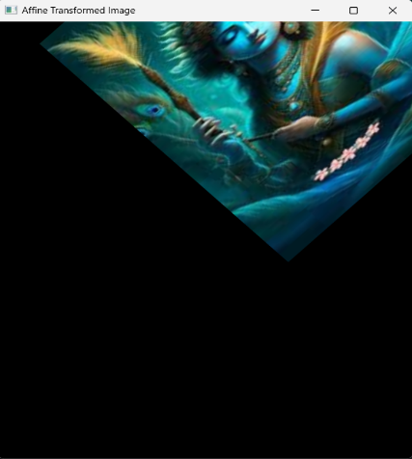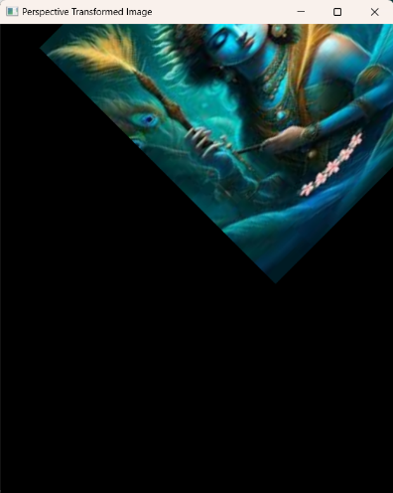

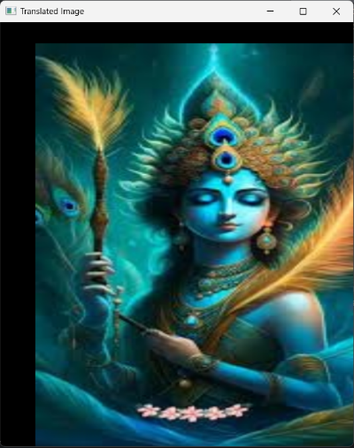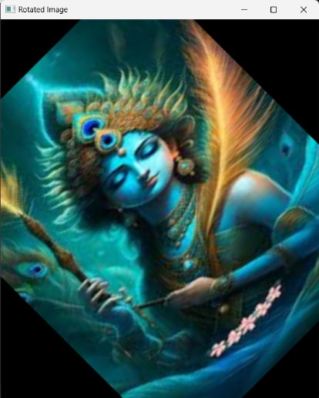

(Output Images- Colour)

## 1)Geometric Transformation (Code):

import cv2  
import numpy as np  
  
def geometric_transformations(image_path):  
 img = cv2.imread(image_path)  
 rows, cols = img.shape[:2]  
  
 # Translation  
 translation_matrix = np.float32([[1, 0, 50], [0, 1, 30]]) # Shift by (50, 30)  
 translated_img = cv2.warpAffine(img, translation_matrix, (cols, rows))  
  
 # Rotation  
 rotation_matrix = cv2.getRotationMatrix2D((cols / 2, rows / 2), 45, 1) # Rotateby 45 degrees  
 rotated_img = cv2.warpAffine(img, rotation_matrix, (cols, rows))  
  
 # Affine Transformation (combination of translation, rotation, scaling, and shearing)  
 affine_matrix = np.float32([[0.5, 0.5, 50], [-0.5, 0.5, 30]]) # Custom affine matrix  
 affine_transformed_img = cv2.warpAffine(img, affine_matrix, (cols, rows))

# Perspective Transformation  
 perspective_matrix = np.float32([[0.5, 0.5, 50], [-0.5, 0.5, 30], [0, 0, 1]])  
 perspective_transformed_img = cv2.warpPerspective(img, perspective_matrix,(cols, rows))

cv2.imshow('Original Image', img)  
 cv2.imshow('Translated Image', translated_img)  
 cv2.imshow('Rotated Image', rotated_img)  
 cv2.imshow('Affine Transformed Image', affine_transformed_img)  
 cv2.imshow('Perspective Transformed Image', perspective_transformed_img)  
  
 cv2.waitKey(0)  
 cv2.destroyAllWindows()

#Usage  
geometric_transformations(r"C:\Users\RAGHUL\Downloads\krishna.jpg")

## Image Blurring (Output):

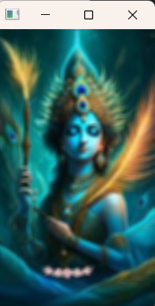

(Input Image-Colour) (Output image-Colour)

## Gausian Blurring (Output):

******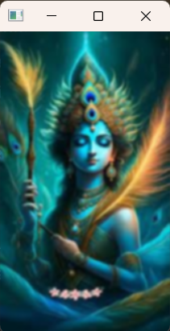

(Input Image-Colour) (Output image-Colour)

## Image Blurring (Code):

import cv2  
image = cv2.imread(r"C:\Users\RAGHUL\Downloads\krishna.jpg")  
average_blurred_image = cv2.blur(image, (5, 5))  
cv2.imshow("Original image",image )  
cv2.imshow("Average Blurred Image", average_blurred_image)  
cv2.waitKey(0)  
cv2.destroyAllWindows()

## Gausian Blurring (Code):

import cv2  
image = cv2.imread(r"C:\Users\RAGHUL\Downloads\krishna.jpg")  
blurred_image = cv2.GaussianBlur(image, (5,5), 0)  
cv2.imshow("Original image",image )  
cv2.imshow("Gaussian Blurred Image", blurred_image)  
cv2.waitKey(0)  
cv2.destroyAllWindows()

## Bilateral Blurring (Output):

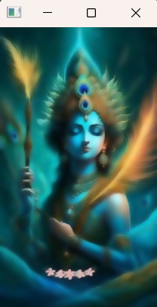



(Input Image-Colour) (Output image-Colour)

## Median Blurring (Output):

******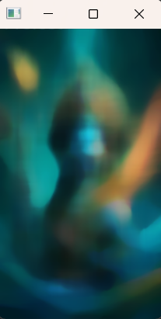

(Input Image-Colour) (Output image-Colour)

## Bilateral Blurring (Code):

import cv2  
image = cv2.imread(r"C:\Users\RAGHUL\Downloads\krishna.jpg")  
bilateral_filtered_image = cv2.bilateralFilter(image, 9, 175, 715)  
cv2.imshow("Original image",image )  
cv2.imshow("Bilateral Filtered Image", bilateral_filtered_image)  
cv2.waitKey(0)  
cv2.destroyAllWindows()

## Median Blurring (Code):

import cv2

image = cv2.imread (r"C:\Users\RAGHUL\Downloads\krishna.jpg")

median_blurred_image = cv2.medianBlur(image, 25)

cv2.imshow("Original image",image )

cv2.imshow("Median Blurred Image", median_blurred_image)

cv2.waitKey(0)

cv2.destroyAllWindows()

## User Defined Average Blurring (Output):

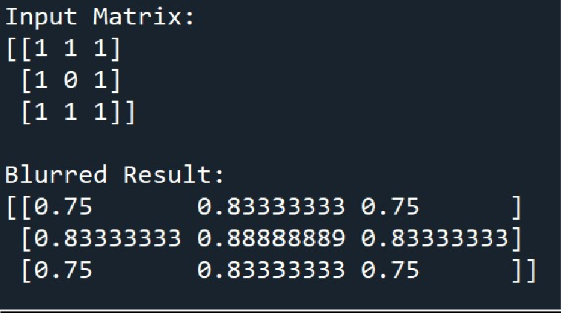

(Output in Terminal )

## User Defined Average Blurring (Code):

import numpy as np

def average_blurring(input_matrix, kernel_size): rows, cols = input_matrix.shape

blurred_matrix = np.zeros_like(input_matrix, dtype=float) kernel_radius = kernel_size // 2

for i in range(rows): for j in range(cols):

pixel_sum = 0.0

count = 0

for m in range(-kernel_radius, kernel_radius + 1): for n in range(-kernel_radius, kernel_radius + 1):

if 0 <= i + m < rows and 0 <= j + n < cols: pixel_sum += input_matrix[i + m, j + n] count += 1

blurred_matrix[i, j] = pixel_sum / count return blurred_matrix

input_matrix = np.array([[1, 1, 1],

[1, 0, 1],

[1, 1, 1]])

kernel_size = 3

blurred_result = average_blurring(input_matrix, kernel_size)

print("Input Matrix:") print(input_matrix) print("\nBlurred Result:") print(blurred_result)

## 3)Thresholding (Output):

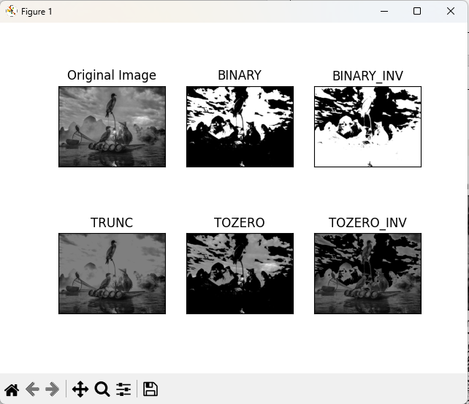(SIMPLE THRESHOLDING)

(ADAPTIVE THRESHOLDING)

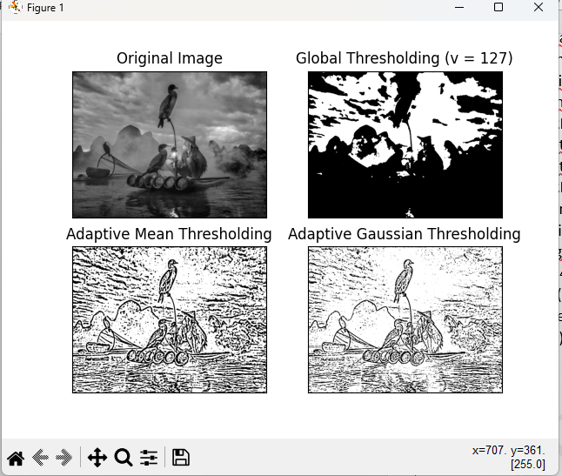

## 3)Thresholding (Code):

**SIMPLE THRESHOLDING**

import cv2 as cv  
import numpy as np  
from matplotlib import pyplot as plt  
img = cv.imread(r"X:\BIRD.jpg", cv.IMREAD_GRAYSCALE)  
assert img is not None, "file could not be read, check with os.path.exists()"  
ret,thresh1 = cv.threshold(img,127,255,cv.THRESH_BINARY)  
ret,thresh2 = cv.threshold(img,127,255,cv.THRESH_BINARY_INV)  
ret,thresh3 = cv.threshold(img,127,255,cv.THRESH_TRUNC)  
ret,thresh4 = cv.threshold(img,127,255,cv.THRESH_TOZERO)  
ret,thresh5 = cv.threshold(img,127,255,cv.THRESH_TOZERO_INV)  
titles = ['Original Image','BINARY','BINARY_INV','TRUNC','TOZERO','TOZERO_INV']  
images = [img, thresh1, thresh2, thresh3, thresh4, thresh5]  
for i in range(6):  
 plt.subplot(2,3,i+1),plt.imshow(images[i],'gray',vmin=0,vmax=255)  
 plt.title(titles[i])  
 plt.xticks([]),plt.yticks([])

plt.show()

**ADAPTIVE THRESHOLDING**

import cv2 as cv  
import numpy as np  
from matplotlib import pyplot as plt  
img = cv.imread(r"X:\BIRD.jpg", cv.IMREAD_GRAYSCALE)  
assert img is not None, "file could not be read, check with os.path.exists()"  
img = cv.medianBlur(img,5)  
ret,th1 = cv.threshold(img,127,255,cv.THRESH_BINARY),\  
 cv.THRESH_BINARY,11,2)  
th2 = cv.adaptiveThreshold(img,255,cv.ADAPTIVE_THRESH_MEAN_C  
th3 = cv.adaptiveThreshold(img,255,cv.ADAPTIVE_THRESH_GAUSSIAN_C,\  
 cv.THRESH_BINARY,11,2)  
titles = ['Original Image', 'Global Thresholding (v = 127)',  
 'Adaptive Mean Thresholding', 'Adaptive Gaussian Thresholding']  
images = [img, th1, th2, th3]  
for i in range(4):  
 plt.subplot(2,2,i+1),plt.imshow(images[i],'gray')  
 plt.title(titles[i])  
 plt.xticks([]),plt.yticks([])  
plt.show()

**(Otsu’s Thresholding )**

****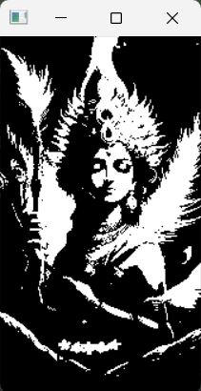**

**Input Image** **Output Image**

**Otsu’s Thresholding:**

import cv2  
import numpy as np  
  
image1 = cv2.imread(r"C:\Users\RAGHUL\Downloads\krishna.jpg")  
  
img = cv2.cvtColor(image1, cv2.COLOR_BGR2GRAY)  
  
ret, thresh1 = cv2.threshold(img, 120, 255, cv2.THRESH_BINARY +  
 cv2.THRESH_OTSU)  
  
  
cv2.imshow('Otsu Threshold', thresh1)  
  
if cv2.waitKey(0) & 0xff == 27:  
 cv2.destroyAllWindows()

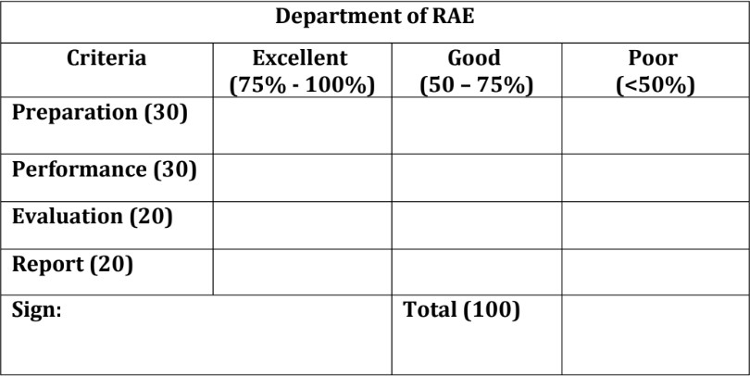

# Result:

Thus, the Geometrical Transformations and Filtering Techniques were learnt using OpenCV.

# Post Lab Questions:

1. What is the difference between affine transformation and perspective transformation?
2. What do you mean by cartooning?
3. What does the filter2D function do? Explain with the arguments
4. Write a program for Ostu’s thresholding without using inbuilt function

# Post Lab Answers:

1. Difference between affine transformation and perspective transformation:
   * **Affine Transformation:** Preserves parallel lines in an image. It includes operations like translation, rotation, scaling, and shearing, where lines remain parallel before and after transformation.
   * **Perspective Transformation:** Involves transformations that allow perspective distortion, where parallel lines might converge or diverge. This transformation is more general and includes changes that aren't solely based on affine operations.
2. **– Cartooning** refers to the process of rendering images in a simplified or exaggerated manner, often resembling cartoons or illustrations. It involves reducing detail, enhancing outlines, and simplifying colors or shading to create a stylized or artistic effect.

# Explanation of the `filter2D` function with its arguments:

* + `filter2D` is an OpenCV function used for applying a custom convolution kernel to an image.

# Arguments:

* + - `src`: The input image.
    - `ddepth`: Depth of the output image; set to -1 to match `src` depth.
    - `kernel`: The convolution kernel, usually a numpy array.
    - `anchor`: The anchor point of the kernel (default is (-1, -1), which means the center of the kernel).
    - `delta`: Optional value added to the filtered pixels.
    - `borderType`: Specifies the pixel extrapolation method.

# Program for Otsu’s thresholding without using inbuilt function:

* + Here's an implementation of Otsu's thresholding without using the inbuilt

`cv2.threshold` function in Python:

import numpy as np import cv2

def otsu_threshold(image):

pixel_counts = [np.sum(image == i) for i in range(256)] total_pixels = sum(pixel_counts)

sum_b = 0

weight_b = 0

maximum = 0

threshold = 0

for i in range(256):

weight_b += pixel_counts[i] if weight_b == 0:

continue

weight_f = total_pixels - weight_b if weight_f == 0:

break

sum_b += i * pixel_counts[i] mean_b = sum_b / weight_b mean_f = (sum - sum_b) / weight_f

between = weight_b * weight_f * (mean_b - mean_f) ** 2 if between > maximum:

maximum = between threshold = i

return threshold # Example usage

image = cv2.imread('path/to/your/image.jpg', cv2.IMREAD_GRAYSCALE)

threshold_value = otsu_threshold(image)

ret, thresholded_image = cv2.threshold(image, threshold_value, 255, cv2.THRESH_BINARY)

cv2.imshow('Thresholded Image', thresholded_image) cv2.waitKey(0)

cv2.destroyAllWindows()